Article
Public Sector Debt’s Effect on Economic Indicators and Real-Estate Investability
August Blomquist, Oliver Cheng, Alireza Darvishzadeh, Nolan French,
Jimmy Hernandez, Renata Krivenko, Connor Li, Luke Olmos
Saint Mary’s College of California: DATA 496
Abstract: This article analyzes public sector debt’s impact on economic indicators and real-estate investability across OECD countries in support of large U.S.-based private real estate firms. This paper uses statistical analysis, correlation techniques, and debt forecasting methods to determine the extent that public debt influences macroeconomic stability and investment potential. Economic indicators such as Inflation Rate, Unemployment Rate, and GDP growth were used to evaluate if countries could remain viable investment destinations even with high public debt levels. Social indicators like population growth rates, education rates, and corruption indices were used to evaluate the safety and long-term viability of property investments. The research aims to assist Horizon Development in identifying countries that are both fiscally sound and attractive for long-term real estate investment.

Keywords: Public Sector Debt, Real Estate, Investment, Economic Indicators

1. Introduction
Public Sector Debt refers to the amount of money a country’s government and public entities owes, both domestic and foreign. The public sector is made up of the federal government and organizations that operate under the federal government, along with state and state-operated organizations in countries like the US (1). These organizations normally operate for the good of the public, such as public education or public transit systems. Historically, public sector debt was mainly used to finance wars and guarantee border security through use of armies and mercenaries (2). In the 1800s governments started to issue bonds (a form of IOU that allows citizens to lend money to the government in return for interest) in order to finance public works such as infrastructure or education systems (3). In the 20th century, there was a large increase in the debt burdens on countries, likely due to the world wars and financial crises such as the Great Depression. These debt burdens were gradually resolved, but public sector debt rose throughout the world in order to fund social services such as pensions and health care.
Prominent economic experts have increasingly studied the relationship between public sector debt conditions, crime and education rates, and key economic indicators in OECD nations. Public sector debt conditions are best measured through metrics such as Average Debt, Debt-to-GDP, and Government Expenditure as a percentage of GDP. Key economic indicators are considered to be Real Inflation Rate, GDP Growth Rate, Unemployment Rate, Foreign Direct Investment (FDI), and Population Growth Rate. Many academic journals have examined fiscal sustainability’s impact on long-term financial health for these nations. Their results provide insight into public sector debt’s deleterious effect on investment attractiveness for major real-estate investment firms.
It is also important to use a holistic approach to determining investment attractiveness, considering elements like sovereign credit rating, monetary policy flexibility, and sector-specific risks. Qualitative factors such as geopolitical risks, regulatory stability, and compatibility with a firm’s core values must be considered for major investment decisions. Counterexamples such as the United States and Japan demonstrate that countries can remain desirable investment destinations due to monetary stability, a booming private sector, and strong fiscal policies even with high public debt levels. In this study, we will use statistical modeling, binary classification, real-world trends, and qualitative factors to cluster OECD nations based on their investment desirability to Horizon Development, a leading U.S. real-estate firm.

1.2. Literature Review
The 2024 work “Why the National Debt Matters for Housing” [1] by the Bipartisan Policy Center studies the effects of high public sector debt levels on housing. Their findings suggest that high debt levels weaken the government’s support of affordable housing initiatives. Consequently, reduced government spending increases mortgage rates and prevents low and middle-income households from affording proper housing. This debt also exacerbates existing supply-chain shortages and weakens investor sentiment in the bond market. This negative sentiment can lead to higher yields on government bonds, causing higher borrowing costs. Overall, not stabilizing debt levels can perpetuate the existing housing crisis by reducing government spending, weakening investor sentiment, and increasing mortgage rates.
The 2022 study “How Will Inflation Impact Commercial Real Estate” [2] by NAIOP, the Commercial Real Estate Development Association, analyzes inflation’s negative impact on the commercial real estate (CRE) sector. High public sector debt levels can lead to expansionary fiscal policies, which are linked to higher inflation rates. Inflationary pressures can drive up construction costs and rent prices, perpetuating the ongoing housing crisis. They also can cause higher borrowing costs and reduced CRE demand, creating investment uncertainty deterring long-term contracts. Countries with high public sector debt levels face limited fiscal flexibility to lessen inflation in the CRE sector, making them generally less desirable investment destinations. NAIOP encourages prudent fiscal and monetary policies to improve CRE sentiment and lessen rising inflation and public debt levels.
The 2021 study “The OECD Economic Outlook” [3] discusses the post-COVID challenges that advanced and emerging economies currently face. Public sector debt levels have reached unprecedented highs due to fiscal and monetary policies aimed at mitigating the negative financial effects of pandemic restrictions. OECD advises countries to initiate fiscal consolidation strategies following the end of the COVID-19 crisis to restore economic stability. They find that debt sustainability is also affected by investments in specific sectors such as technology, infrastructure, and innovation. They warn that high debt levels can negatively affect the private sector by crowding out investment, particularly in emerging and lower-income countries. They encourage countries to analyze public sector debt in conjecture with long-term growth strategies.
In the 2024 article “Modern Monetary Theory and its Implications for Public Debt” [4], Mitchell and Wray offer an alternative perspective to this paper’s findings and aim. MMT views sovereign countries with their own currency, such as those not in the Eurozone, can essentially print money to finance fiscal deficits to avoid the consequences of budget deficits. They view inflation, not the threat of sovereign debt, as the only limit to deficit spending. According to MMT, large-scale public debt may not be as harmful as traditional economic wisdom holds. Effective fiscal policies measures through taxation and government spending can mitigate inflation and prevent “overheating” in the economy. While critics argue that MMT causes hyperinflation and lessens investor sentiment, they argue it can enhance public investment without worsening debt sustainability. They stress that countries must have effective governance and proven fiscal and monetary policies to maintain economic stability and reasonable inflation levels to successfully apply MMT.
In the 2019 work “Public Debt and Low Interest Rates”, [5] Blanchart argues that a country can mitigate high debt levels by having its economic growth rate exceed its borrowing cost. He emphasizes that externalities, shifts in investor sentiment, and monetary policy changes can still impact a country’s financial health. He views persistently low interest rates as potentially mitigating rising concerns about debt sustainability.
In the 2012 work “The impact of high government debt on economic growth” [6], Checherita-Westphal and Rother consider debt’s impact on economic sustainability in the European Union. According to research, high debt levels kickstart negative growth effects when Debt-to-GDP levels reach approximately seventy-five percent. They found that failures in fiscal policy transmission, such as public investment, and total factor productivity, cause the correlation between high debt rates and low long-term growth rates. They also emphasized that governmental response to rising debt levels, such as structural reforms, productivity growth, and lower debt growth rates, can help mitigate economic slowdowns caused by excessive public debt.
Comparatively, in the 2015 work “Public debt, economic growth, and nonlinear effects: Myth or Reality?,” [7] Egert emphasizes that countries whose debt-to-GDP ratio exceeds 90% can mitigate slowed growth rates through effective governance and transparent fiscal policies. Compared to Rogoff and Rother, he is more opposed to using a universal debt threshold to measure economic stagnation risk due to non-linear effects like governance and economic stability.
The 2016 study “Great Mortgaging: Housing Finance, Crises, and Business Cycles” [8] by Jordà, Schularick, and Taylor finds that economic downturns are usually associated with dramatically increased levels of public sector debt. Their research encourages emerging economies to develop better debt sustainability frameworks. These findings explain how public debt affects financial differentiation among nations and their economic scores, such as credit ratings, GDP growth, inflation control, and fiscal balance. Countries with sustainable debt levels will usually score higher in these indicators due to their better economic performance. Meanwhile, high-debt nations have higher borrowing costs and greater economic instability that negatively affect their economic performance. Overall, this work reveals that fiscal stability and debt sustainability usually improve a country’s economic score through an enhanced credit rating.
In the 2010 work “Growth in a Time of Debt” [9], Reinhart and Rogoff argue that countries will suffer low growth rates if their public sector debt is at least ninety percent of their GDP. High-debt countries have a one percent lower median GDP growth rate and an even lower mean growth rate than other lower-debt countries. Additionally, their research suggests that a significant correlation exists between high debt levels and rising inflation levels in emerging markets. They found that countries may damage consumer confidence and risk unforeseen financial catastrophes if they excessively borrow money to repay their debt. However, this study remains controversial and fiercely debated due to alleged computational errors and unfounded findings on arbitrary debt thresholds. Critics argue that this study takes an excessively reductionist approach by failing to consider qualitative factors like monetary policy, external economic conditions, and effective governance. For example, countries can use monetary policy tools like interest rates and quantitative easing to prevent high-debt levels from causing lower growth rates.
Finally, Freddie Mac’s 2021 report, “As the Population Keeps Growing, So Do Housing Needs” [10], examines the relationship between population growth and housing demand. Their forecasts suggest that due to population growth and demographic shifts, the United States will need approximately four million new homes in the next ten years. They view high public sector debt levels as a central threat to weakening the housing supply. Their findings suggest that these high debt levels prevent the government from properly financing infrastructure and housing programs. They also view high public sector debt as driving up inflation rates, making it financially impossible for many citizens to afford housing. They advocate for continued governmental support of low-income housing while maintaining reasonable debt levels.

1.3. Similar Work and Context
Institutions such as the IMF and World Bank have recently begun studying public sector debt’s effect on key economic indicators. Their findings call for more careful fiscal policies in higher-risk, less stable OECD countries like Chile and Greece. The European Central Bank has found that central banks must be able to manage inflation and interest rates effectively even with high debt levels.
Comparatively, this study uses findings gathered from the literature review with relevant economic modeling and scoring to assess the impact of debt on investment attractiveness for OECD nations. By using binary classification and several machine learning algorithms, this research hopes to show a more specific impact of high debt levels on GDP growth, unemployment, and inflation.
This paper’s analysis builds upon previous research findings by using six datasets from thirty-seven OECD countries from 2010 to 2023. Unlike traditional academic journals, this paper hopes to compare multiple economic zones and OECD economies to identify multi-year trends.
This paper is being written in the middle of an international trade war, which involves many OECD countries and which public debt is a prime factor in.

1.4. Aim of Paper
The main objective of this project is to understand the effects of public sector debt on key economic indicators and real estate profitability. This paper seeks to answer the research question of, “How does Economic Status and Public Sector Debt Affect Real Estate Investability?”
This paper aims to assess public debt conditions, analyze real estate, socioeconomic, and political trends, and identify causes of public debt levels for thirty seven OECD nations selected by Horizon Development. The paper’s primary objective is to assess desirable and undesirable target markets for Horizon Development to expand into based on real-world data, statistical modeling, and trends in the political and real-estate dimensions. This study will provide Horizon Development with a better understanding of macroeconomic stability in each country, guiding their investment decision-making. Countries with high debt levels may still be a recommended target market based on their fiscal policies, political and economic stability, and debt sustainability. Conversely, countries with low debt levels still may not be recommended if their values are inconsistent with Horizon’s or concerning trends from 2010 to 2023 are identified by the model. Overall, this paper’s primary aim is to use trends, modeling, and public sector debt levels to cluster the OECD countries based on their investment desirability to Horizon.
1.5. Structure of Paper
This paper is organized into eight sections. The title and abstract will identify this study’s main objective, findings, and conclusions. The Introduction will include a definition of our measures, a Literature Review, a Similar Work and Context section, an Aim of Presentation section, and a Structure of Paper section. The Introduction will place this study in the context of other academic works while establishing Horizon Development’s vision with this project. The Methodology section will describe the study’s work performance. The Results section will include the study’s data, relevant data visualizations, and brief comments for Horizon decision-makers. The Discussion section will include analysis of results, including unexpected findings and outliers. It will compare the findings with the paper’s original aim and address any lingering research questions. The Conclusions section will summarize our findings and objectives. The References will feature our sources analyzed in the Literature Review and used to enhance our understanding of the topic at hand.

2. Methodology
A group of eight students in the Data Science Capstone at Saint Mary’s College of California was tasked with evaluating OECD countries for their real estate sustainability to provide strategic recommendations for Horizon Development. They were instructed to prioritize factors relating to real estate and the broader economy–specifically interest rates, public sector debt, education levels, crime rates, unemployment, inflation, and GDP–while excluding countries currently experiencing economic distress or projected to face economic distress by 2030.
A total of seventeen datasets were used for modeling and statistical analysis. Five of these datasets were obtained from the OECD website, via the course professor. These datasets were Inflation Percentage, National GDP in USD, Unemployment Rate, Standardized Population Growth Rate, Public Sector Debt (% of GDP), and Annual Inflation Percentage. These datasets contained relevant data for thirty-seven OECD nations, excluding Israel, spanning from 2010 to 2023. Data prior to 2010 included in the original CSV files was filtered out by students. Each student utilized Python and relevant libraries, including pandas, to clean, filter, and analyze datasets drawn. These filtered data sets were then reuploaded into a shared class Google Drive folder. Relevant datasets had Country Codes and missing countries added. GDP (USD) was converted to year-over-year growth. Crime Index (2025) and Education Rate (2024) were obtained from World Population Review. Annual Inflation Rate (2010-2023) was found on the World Bank and the non-OECD countries were filtered out. Consumer Price Index (CPI), Tax Revenue (% of GDP), Urban Population Growth Rate, GDP per Capita, Foreign Direct Investment (FDI), Export of Goods & Services, Imports of Good & Services, Current Account Balance (USD), and Labor Force Participation Rate were also used, obtained via the World Bank DataBank. Housing Pricing Indicator and Corruption Perception Index were obtained via external sources. All datasets were imported into Python using Google Colab.

2.1. Data Preprocessing
All variables were converted into year-over-year (YoY) using Google Colab. The target variable was defined as Public Sector Debt (% of GDP). The feature variables were defined as economic indicators that were statistically significant at the 0.05 significance level. The regions were European countries, non-European countries, and all 37 OECD countries. 26 countries are classified as European countries, with the remaining 11 classified as non-European.
The years 2010 - 2023 were broken up into four distinct files. 2010-2012 measures the economic pressures of the Eurozone Crisis. 2014 - 2019 measures a relatively normal period with few outside factors and relatively standard growth rates. 2020 - 2021 measures how countries were affected and responded to the COVID-19 pandemic and economic restrictions such as lockdowns associated with them. 2022 - 2023 measures a post-COVID era to see how countries can recover from pandemic situations.
Three distinct scenarios were considered for calculating public sector debt growth from 2024 to 2030. One scenario was a normal scenario where the years 2014 - 2019, the normal period, were used to predict what the public sector debt would be. Another scenario will be a pandemic situation using the 2020-2021 and 2022-2023 data files. A third scenario will be an economic recession scenario, an increasing concern by major firms like Goldman Sachs and JPMorgan Chase & Co., using data from 2010-2012.
After defining the country groups and regions, the dataset dictionary must be defined. The dictionary maps factors to DataFrames such as df_debt and df_export. These datasets are then merged into df_actual (2010-2023) where the first column will be named “Country.” The 2014 - 2019 normal period trends will be extracted into df_normal.

2.2. Correlation and Weights
For each group, Pearson Correlation Coefficients were calculated between Public Debt each factor using scipy.stats.pearsonr. Correlations were filtered by p < 0.05 significance level to ensure statistical significance. Statsmodel.api was used for linear regression to have a second metric for correlation significance.
The purpose of using Correlation was to derive weights for public sector debts. Significant correlations, where p <0.05, were converted into weights for the normal scenario. Weights were calculated by taking the absolute value of each correlation to ensure positive weights. The correlation coefficients of all factors were added up. Each correlation was divided by the total for normalization purposes, ensuring the weights sum to one.
These weights play a crucial role in prediction. They determine the influence of each factor on public Debt growth in the different scenarios. For example, a high Inflation weight (0.197 European) means rising inflation significantly increases debt growth.
The Ordinary Least Squares method will be used due to the large amount of input variables used. These will be used to fit a linear regression line to predict future public debt growths or decreases.

2.3. Model One: The Normal Scenario
The average annual change from 2014 - 2019 was first computed for each factor per country, stored in avg_changes. The normal weights were used to compute a yearly growth rate for Public Debt. The growth rate is influenced by normalized factors. These factors were normalized using the formula adjustment = sum(weight * normalized_factor) where normalized_factor reflects the year-over-year (YoY) change in each factor.
Three methods were applied to project the public debt YoY growth rate from 2024 to 2030.
An Average Method was computed, calculating the average YoY growth rate from 2014 - 2019 for each country. This constant rate was applied annually from 2024 to 2030 to project public debt, starting from the 2023 value. The formula Public_Debt_t = Public_Debt_{t-1} * (1 + avg_growth_rate) was used in computing this method.
A Linear Method was used by fitting a linear regression to the YoY growth rates of Public Debt from 2014 - 2019 for each country. The year was used as the predictor. The linear trend was extrapolated to compute the growth rate for each year from 2024 to 2030. The formula growth_rate_t = slope * t + intercept was used. The growth rate Public_Debt_t = Public_Debt_{t-1} * (1 + growth_rate_t) was then applied.
A Quadratic Method was used by fitting a quadratic regression to the YoY growth rates of Public Debt from 2014 - 2019 for each country. The year was used as the predictor. The formula (growth_rate_t = a * t^2 + b * t + c) was used to calculate the growth rate. The quadratic trend was extrapolated to compute the growth rate for each year from 2024 to 2030 and was subsequently applied. The formula used was Public_Debt_t = Public_Debt_{t-1} * (1 + growth_rate_t).
For all methods, the Public Debt projection was adjusted by incorporating the weighted influence of other factors using the formula Public_Debt_t = Public_Debt_t * (1 + adjustment).

2.4. Model Two: Disease Scenario
The same steps were repeated but using 2020 - 2021 and 2021 - 2022 data to obtain each country’s ability to recover from an unexpected natural disaster or pandemic.

2.5. Model Three: Economic Recession Scenario
The same steps were repeated but using 2020 - 2021 and 2021 - 2022 data to obtain each country’s ability to recover from an economic recession.
2.5. Limitations
One significant limitation is missing or null data. For example, it was difficult to obtain accurate and up-to-date information for the government's expenditure on education. The World Bank abruptly halted their collection of this data in 2022 while the rest of our data was collected through 2023. Similarly, the World Bank did not even collect data for one OECD country, Colombia.
Another issue is multicollinearity, as many of our feature variables such as population growth rate and urban population growth rate may be highly correlated with one another. Additionally, the Labor Force has a severely high VIF of 1300, which skews our results. It also increases the difficulty in identifying how each individual variable affects the outcome.
Another issue is that many important variables, such as inflation, were deemed insignificant using the 0.05 significance level. While a country’s inflation is considered very important to real-estate developers, the p-value was 0.2092, meaning inflation was not adequately considered by our modeling.
The applicability to real-world investment decision-making is limited by qualitative factors not considered by binary classification, clustering, time-series analysis, and machine learning models used by the paper. The paper only briefly addresses regulatory stability, property rights enforcement, and upcoming geopolitical threats. Investment firms would be remiss not to consider these factors, which were difficult to classify and categorize with the datasets used. Hence, the practical value to real estate investors moving forward may be limited as news events and externalities present shockwaves to existing public sector debt levels and fiscal policies.
The paper’s methodology assumes that high debt levels are a universal warning sign to all potential real-estate investors. However, counterexamples like Japan and the United States demonstrate why this may not always be the case. Additionally, some investors may prefer riskier investments that offer potentially higher rates of return. Counter-strategies like investing in distressed assets or higher-yield, higher risk markets may be deemed more suitable for investors depending on their risk tolerance and investment portfolio. Future research should better focus on preferences by percentage for major real estate investors.

3. Results
3.1. Model 1: Normal Conditions (2024 - 2030 Debt Growth Rates)
Method 1: Averages
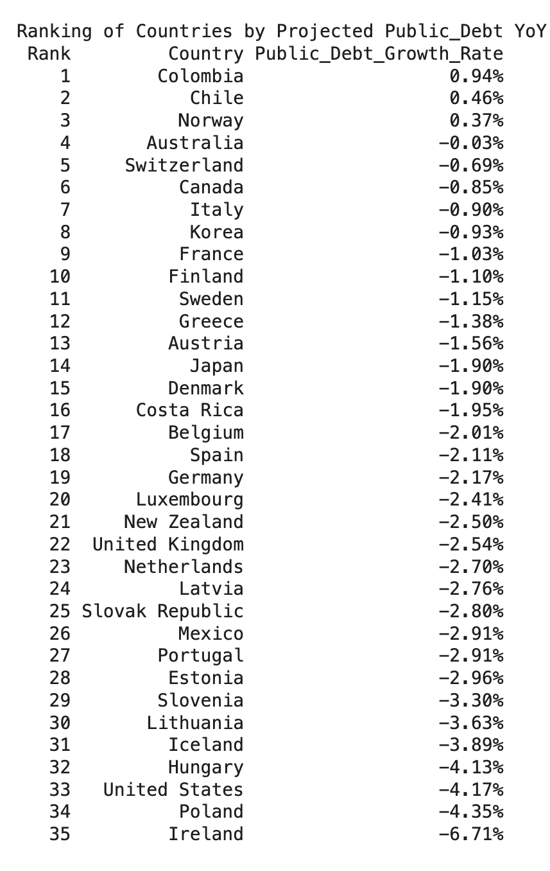
Figure 1. Projected Public Debt Year-over-Year (YoY) Growth Rate for 35 OECD Countries from 2024 - 2030 using Averages
As seen in Figure 1, only Colombia, Chile, and Norway are expected to see a positive increase in their public debt year-over-year growth rate from 2024-2030.

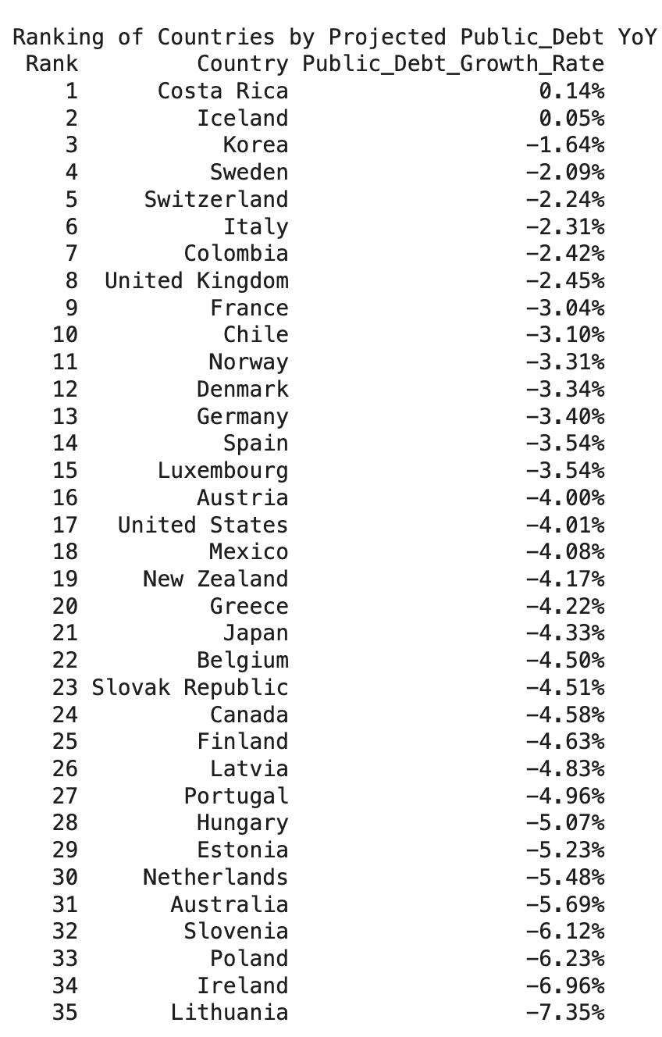
Method 2: Linear Regression

Figure 2. Projected Public Debt Year-over-Year (YoY) Growth Rate for 35 OECD Countries from 2024 - 2030 using Linear Regression

Method 3: Quadratic Regression

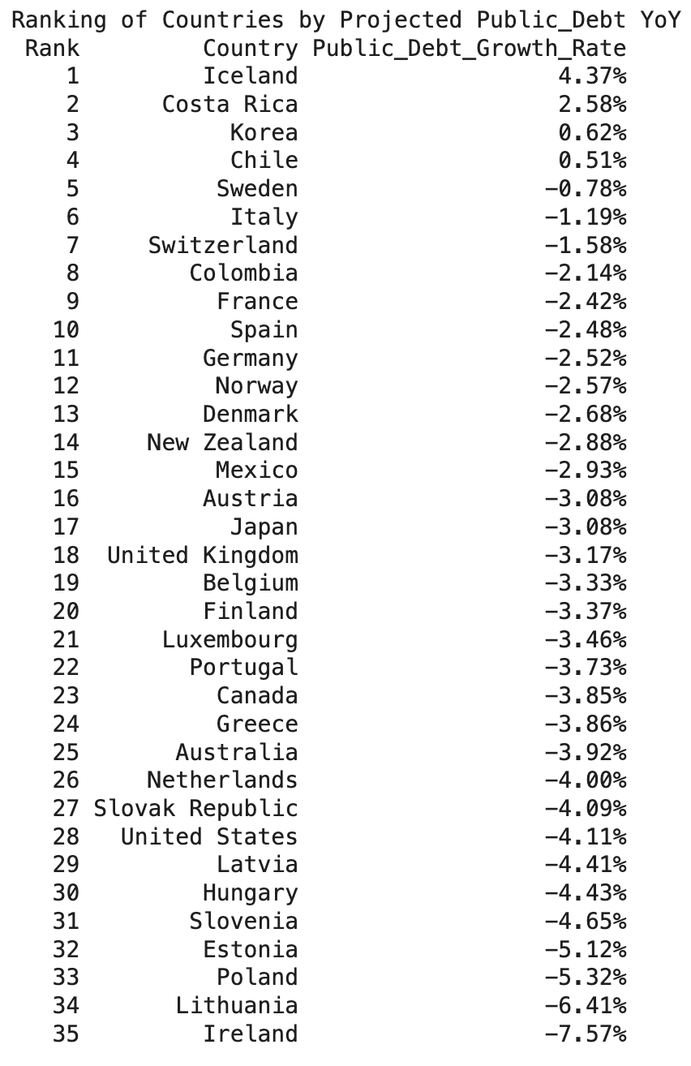

Figure 3. Projected Public Debt Year-over-Year (YoY) Growth Rate for 35 OECD Countries from 2024 - 2030 using Quadratic Regression

3.4 Results without Year Dummy

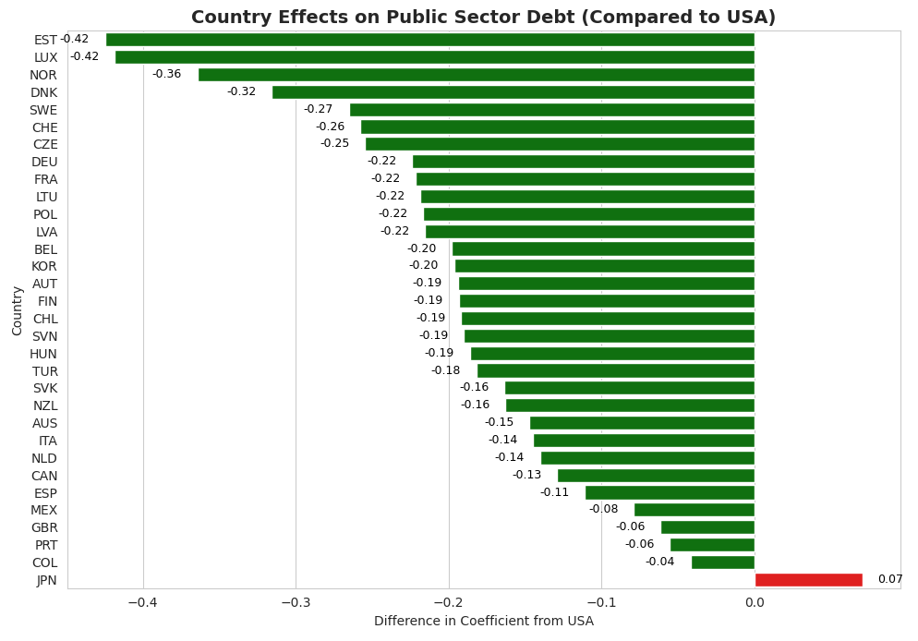

Results using the model without the Year Dummy variable shows that all OECD countries Japan will see decreasing levels of public debt. Estonia, Luxembourg, and Norway have the greatest levels of public debt decrease, whereas Japan’s public debt will grow by 7.09%. The adjusted R-squared value was 0.932, meaning that the regression model explains 93.2% of the variation in this model, which means the model is a good fit.

Costa Rica, Iceland, Ireland, and Greece are excluded from the graph due to high WUI levels (World Uncertainty Index).

3.5 Results with Covid Years Dummy

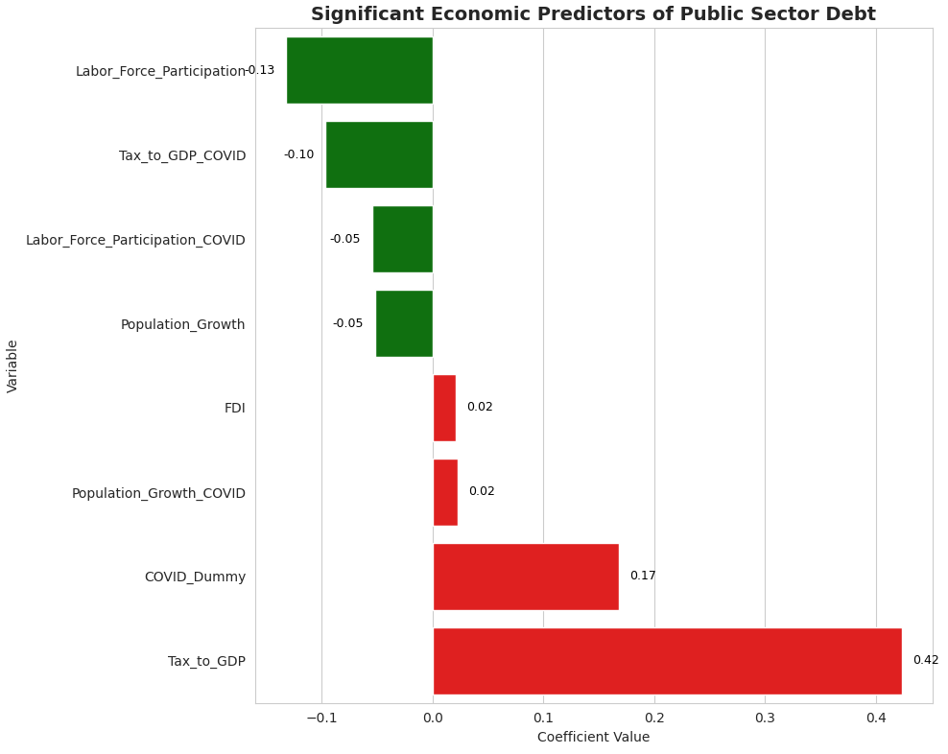
During the Covid years (2020-2021), Labor Force Participation, Tax to GDP ratio, and Population Growth were good indicators of decreasing public sector debt. However, FDI, Tax to GDP ratio during the pandemic, and Population Growth during the pandemic were predictors of increasing public sector debt. The adjusted R-squared value was 0.936, meaning that the model predicted 93.6% of the variation in the data.

3.6 Results with Eurozone Dummy

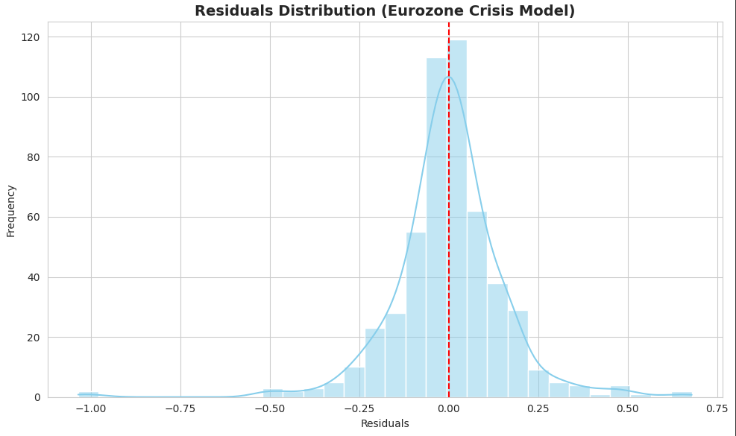

During the Eurozone crisis, debt levels were on average 19% lower. Our adjusted R-squared value was 0.939, meaning the model accounted for 93.9% of variation.

4. Discussions
The vast majority of the OECD countries seem to be trying to decrease their public debt in the upcoming years. Chile, Costa Rica, and Korea are among the few countries whose public debt growth levels have increased (albeit at very low rates, < 1%). Only in the quadratic regression method was there any meaningful increase in public debt growth rate (4.37% for Iceland and 2.58% for Costa Rica).
Poland, Lithuania, and Ireland are the OECD countries that have the highest decrease in public debt growth consistent across the 3 models used. Poland had an average public debt growth of -5.3%, Lithuania of -5.796%, and Ireland with -7.08%. The majority of the countries with the highest decrease in public debt are mainly Eastern European countries.
Most OECD countries have much lower debt levels when compared to the US. This is likely a result of the United State’s baseline high levels of debt. However, countries such as Japan and Greece have much higher debt levels and have struggled with maintaining their debt-to-GDP ratios.
During the Eurozone crisis, public debt levels were down by 19%, which was unexpected due to the crisis being caused by rising public debt levels. However, less than a third of the OECD countries were involved in this crisis, meaning that it could have been balanced out by the non-European countries. Additionally, the crisis started in 2009, so 2010-2012 could be a “recovery period” where governments tried to drastically reduce their public debts.
The Covid model suggests that all countries increased public debt during Covid years (2020-2021), which fits with the monetary policies that were present during covid, such as
Throughout all periods, Estonia, Luxembourg, Norway, and Denmark have maintained high coefficients compared to the US. So far, they seem to be the best countries to recommend.

5. Conclusion
Results are so far not concluded. However GDP and unemployment are highly correlated with high public debt growth.

Acknowledgements: We would like to thank Saint Mary’s College of California, SEBA, and the Business Analytics Department for their support over the last four years. We would like to thank Professor Safwat Hamad for his valuable feedback over the last two months during this project.
Conflicts of Interest: The authors declare no conflict of interest.
References
- Trevino, Aranza. “What Is the Public Sector?” Edited by Anne Cutler and Darren Guccione, Keeper Security Blog - Cybersecurity News & Product Updates, 24 Jan. 2024, www.keepersecurity.com/blog/2022/09/26/what-is-the-public-sector/#:~:text=When%20it%20comes%20to%20ownership,by%20private%20individuals%20and%20companies.
- Stasavage, D (2011), States of Credit: Size, Power, and the Development of European Polities, Princeton University Press.
- Mitchener, Kris, et al. “Public Debt through the Ages .” Public Debt through the Ages | CEPR, 1 Apr. 2019, cepr.org/voxeu/columns/public-debt-through-ages.
- Bipartisan Policy Center. (2024). Why the national debt matters for housing. Retrieved from https://www.freddiemac.com/research/insight/20210128-population-growing
- NAIOP, the Commercial Real Estate Development Association. (2022). How will inflation impact commercial real estate? Retrieved from https://blog.naiop.org/2022/01/how-will-inflation-impact-commercial-real-estate/
- OECD. (2021). Economic Outlook: A comprehensive overview. OECD Publishing.
- Mitchell, W., & Wray, L. R. (2024). Modern monetary theory and its implications for public debt. Retrieved from https://www.themortgagenote.org/how-do-unemployment-rates-affect-the-housing-market/
- Blanchard, O. (2019). Public debt and low interest rates. American Economic Review, 109, 1197–1229.
- Checherita-Westphal, C., & Rother, P. (2012). The impact of high government debt on economic growth. European Economic Review, 56, 1392–1405.
- Égert, B. (2015). Public debt, economic growth, and nonlinear effects: Myth or reality? Journal of Macroeconomics, 43, 226–238.
- Jordà, Ò., Schularick, M., & Taylor, A. M. (2016). The great mortgaging: Housing finance, crises, and business cycles. Economic Policy, 31, 107–152.
- Reinhart, C. M., & Rogoff, K. S. (2010). Growth in a time of debt. American Economic Review, 100, 573–578.
- Freddie Mac. (2021). As the population keeps growing, so do housing needs. Retrieved from https://www.freddiemac.com/research/insight/20210128-population-growing
- Britannica. (n.d.). Eurozone debt crisis. Retrieved from https://www.britannica.com
- Macrotrends. (2023). European Union youth unemployment rate. Retrieved from https://www.macrotrends.net
- Statista. (2024). Youth unemployment rate in EU countries. Retrieved from https://www.statista.com
- OECD. (2020). OECD Economic Surveys: Korea. OECD Publishing. Retrieved from https://www.oecd.org
- World Bank. (2020). Global economic prospects: COVID-19 and the global economy. World Bank. Retrieved from https://www.worldbank.org
- Federal Reserve. (2019). Monetary policy report. Board of Governors of the Federal Reserve System. Retrieved from https://www.federalreserve.gov
- Reuters. (2025). Profits for Colombia’s Ecopetrol slide 22% in 2024. Retrieved from https://www.reuters.com
- Statista. (2023). Economy of Costa Rica – Statistics & Facts. Retrieved from https://www.statista.com
- European Commission. (2020). Latvia: Economic recovery and emigration trends. Retrieved from https://www.ec.europa.eu
- World Bank. (2024). Turkey economic update: Political and market stability. Retrieved from https://www.worldbank.org
- World Bank. (2020). Japan: Employment and Labor Market Overview. Retrieved from World Bank
- OECD. (2020). Economic Survey of Norway. OECD Publishing. Retrieved from OECD
- German Federal Statistical Office. (2020). German Economic Outlook. Retrieved from Destatis
- World Bank. (2016). The Impact of the Oil Price Decline on Developing Countries. World Bank.
- World Bank. (2020). Global Economic Prospects: COVID-19 and the Global Economy. World Bank.
- Daly, Linda, and Jon Ihle. “Will a Booming Economy Sway the Irish General Election?” The Times & The Sunday Times, The Sunday Times, 26 Oct. 2024, www.thetimes.com/world/ireland-world/article/will-a-booming-economy-sway-the-irish-general-election-h9dbbvjv
- Mexico Central Bank Has Growing Inflation Challenge: Extortion | Reuters, www.reuters.com/markets/mexico-central-bank-has-growing-inflation-challenge-extortion-2024-08-27/
- Migration Flows: Eastern, Central and Western Mediterranean Routes - Consilium, www.consilium.europa.eu/en/infographics/migration-flows-to-europe/
- Walter, Rebecca J, et al. “Association between Property Investments and Crime on Commercial and Residential Streets: Implications for Maximizing Public Safety Benefits.” SSM - Population Health, U.S. National Library of Medicine, 30 Nov. 2023, pmc.ncbi.nlm.nih.gov/articles/PMC10757037/
- “Why Is Inflation so Low in Japan?” World Economic Forum, www.weforum.org/stories/2022/10/why-japan-low-inflation/

Previous Versions of this Article
French, Nolan, et al. Real Estate Investment Attractiveness for OECD Countries, 27 Feb. 2025. https://docs.google.com/document/d/1ZAnvB36PPswE60VuJuY019TqEmFDWVXh/edit
Blomquist, August, et al. Real Estate Investment Through Economic Analysis, 27 Feb. 2025. https://docs.google.com/document/d/1XdiaMAmoRjECpTuqYr5HXh6_ZOlMkA-gM7qUS3JcNak/edit?tab=t.0

